**CKTV: EXTRACTING FOLR /Action code mismatch in NCD**

* Note for this M&P Screen shot have been added to visualize it more, as there was no exact ticket or order for this issue

1. The process for FOLR begins by selecting the TFAS hyperlink, either the number ('TfasTktNo') or the blank line itself. When the upper pane refreshes, you'll need – Highlighted in Red- Make sure TFAS status is “F” before we start Process for Extracting FOLR.

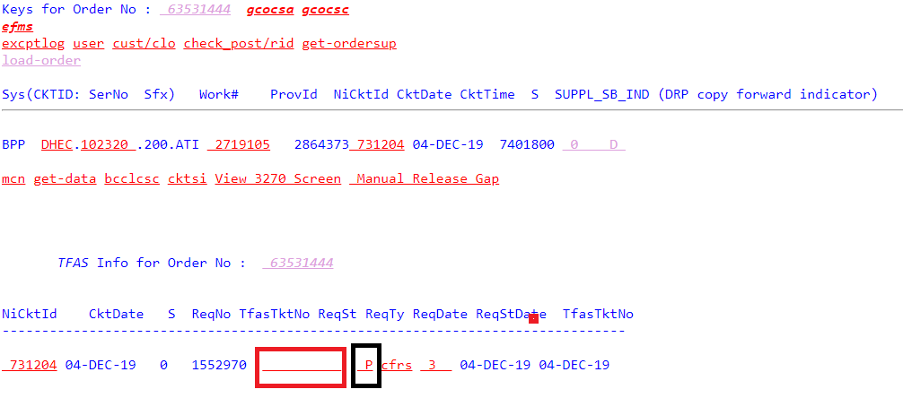

1. We will be taken to next Screen we will need to scroll down for the EXTRACT FOLR box to show, and then click on that box to run the FOLR process. If successful, the Tfas ReqSt will be updated to 'E', indicating that the order is ready for WORD to be issued

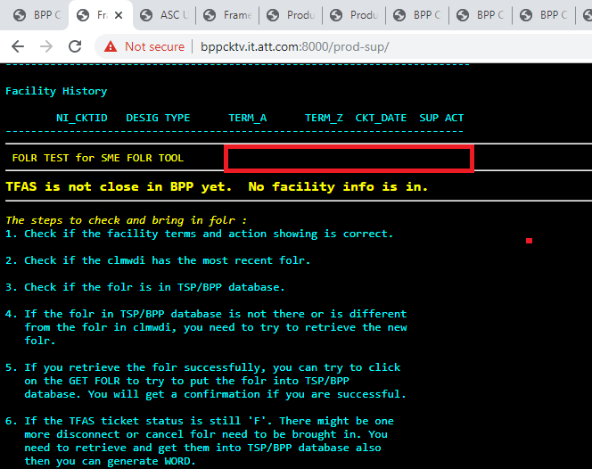

If FOLR has not been extracted properly you won’t see the change of TFAS Status.

1. Then you so should go to SQL Query GUI – webpage and  go to CKTSUBFAS Table and run Query using NI_CKTID

For Example:  SELECT * FROM CKTSUBFAS WHERE NI_CKTID='731204'

Once you Go to further right of the table you will see a field ASGMNT_ACT and there is mismatch of values there. In this example FOLR has no issue but Otherwise you will see the ASGMNT_ACT value as “D”. That needs to be updated .

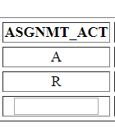

1. To update the Value use the field update and submit- 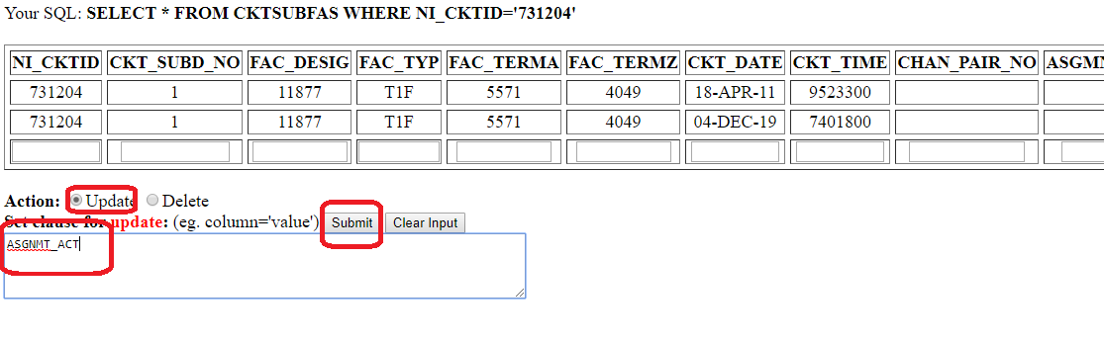
2. Once you have performed this action go back to Step 2
3. You will see the FOLR got Extracted and TFAS staus is changed to E